2025 General Population
Nancy Nash
Manager : Felicia Ford
HR manager : Linda Lewis
.1. Launch Form for Nancy Nash
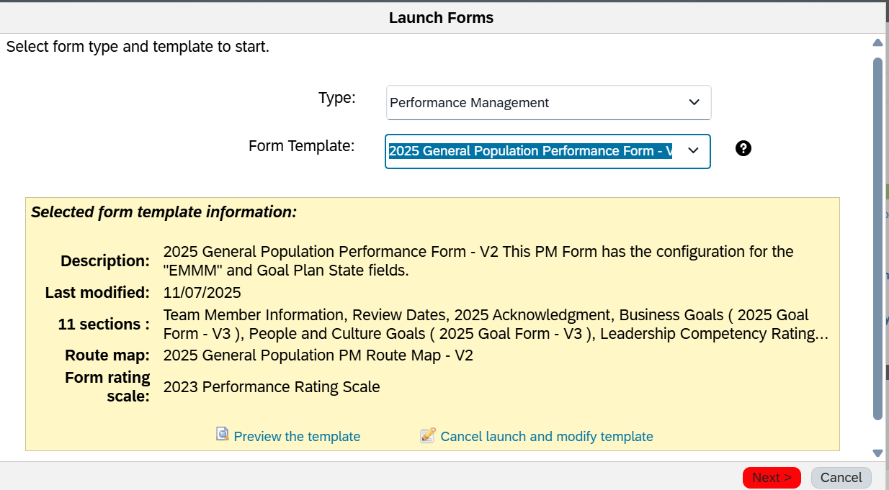
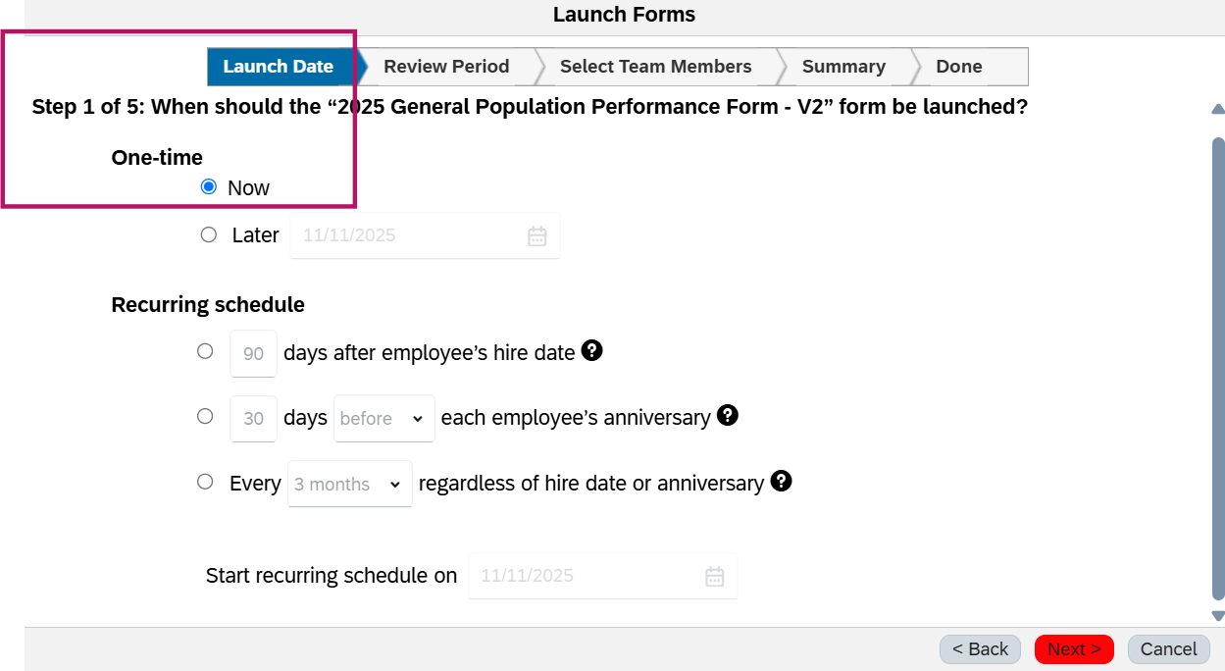
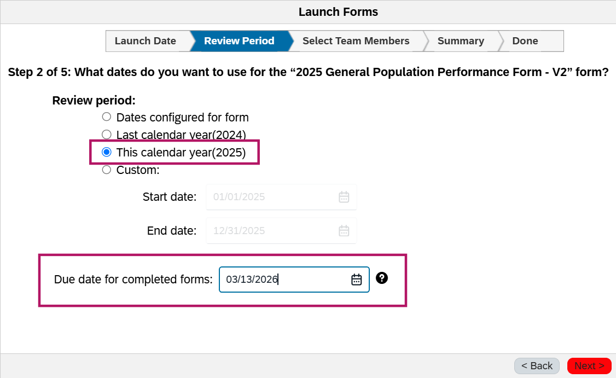
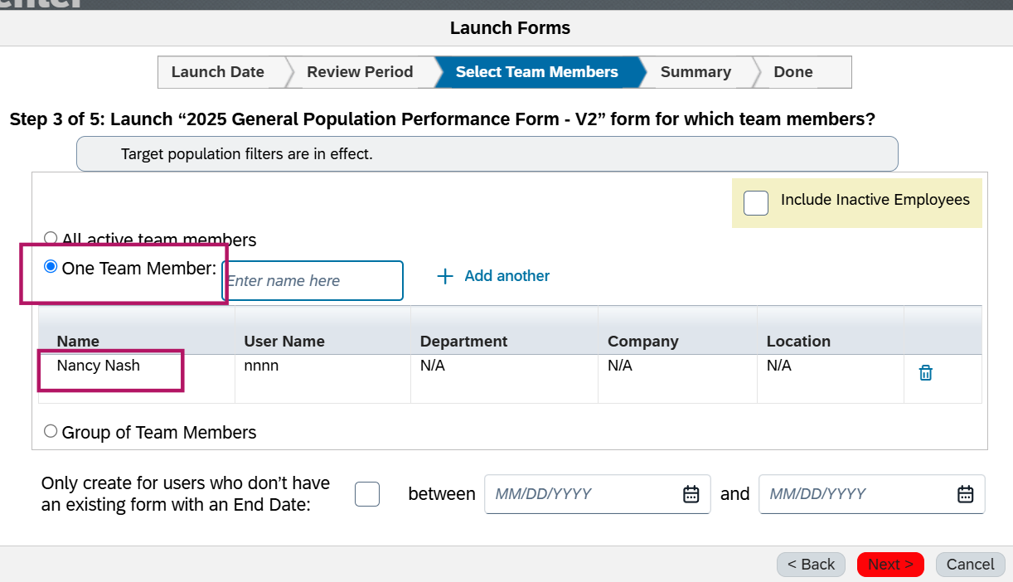
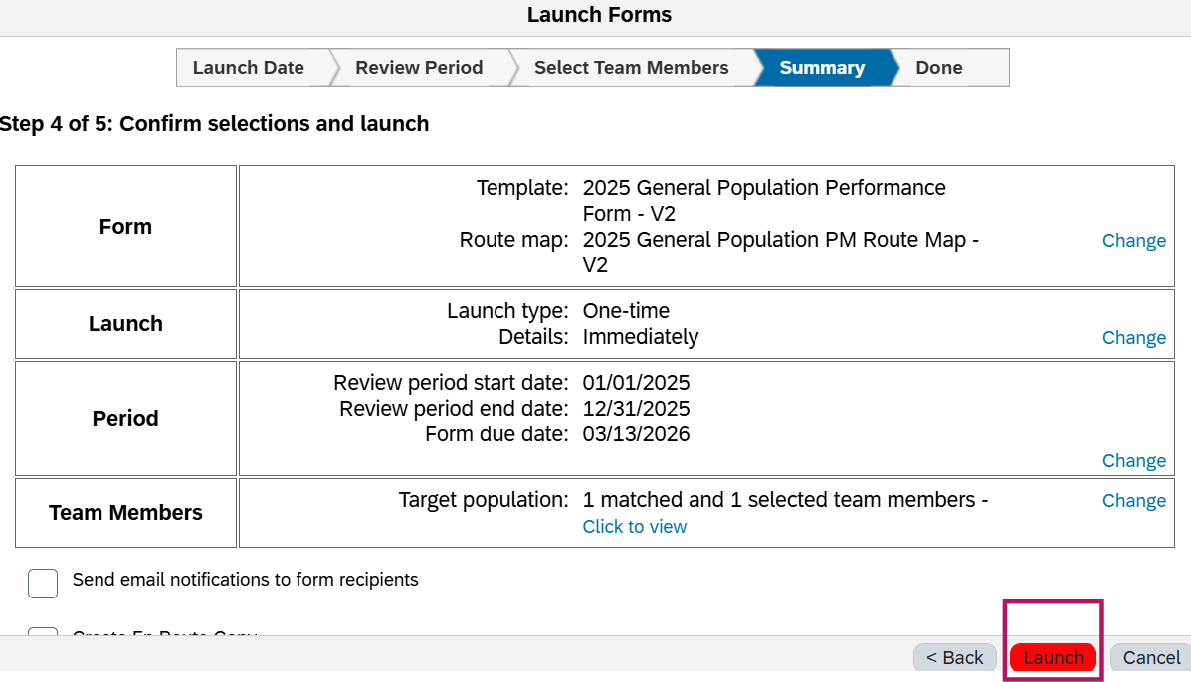
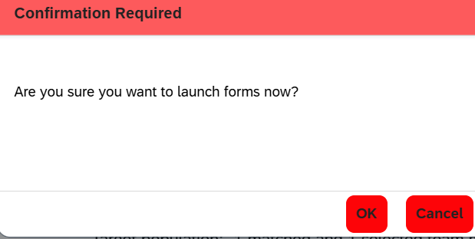
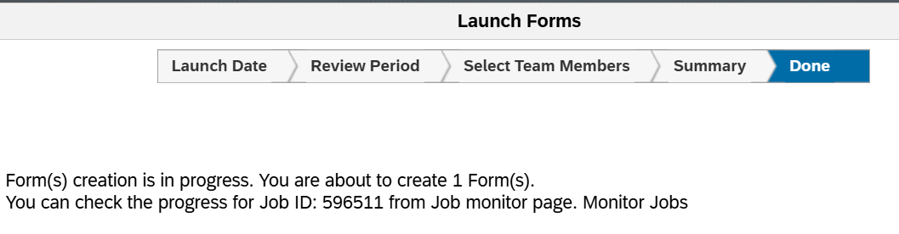

Error screen pops up when Team member tries to ‘send to the next step’
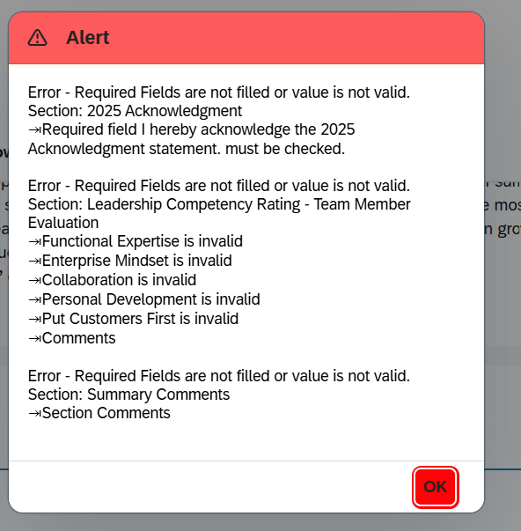
Error screen pops up if ‘Acknowledgement’ box is not checked and tries to move to the next step of the Route form
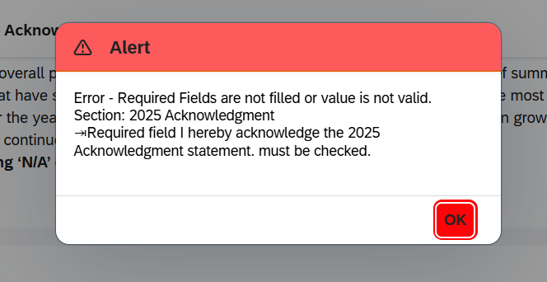

After filling out all the mandatory fields, The form will be forwarded to the next step for manager Assessment
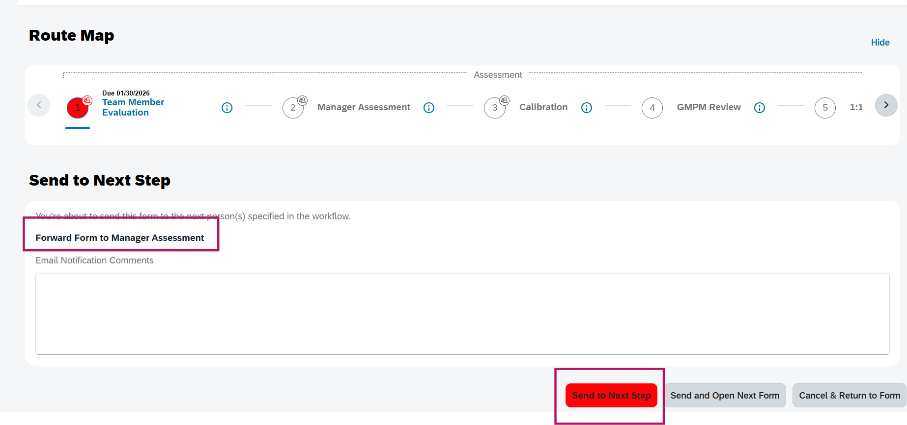
Manager Assessment Step
Proxying as HR Champion and manager- They both can see TM's rating, comments, leadership Competencies and section comments while they are in the manager Assessment Step.

Proxying as HR Champion – Linda Lewis
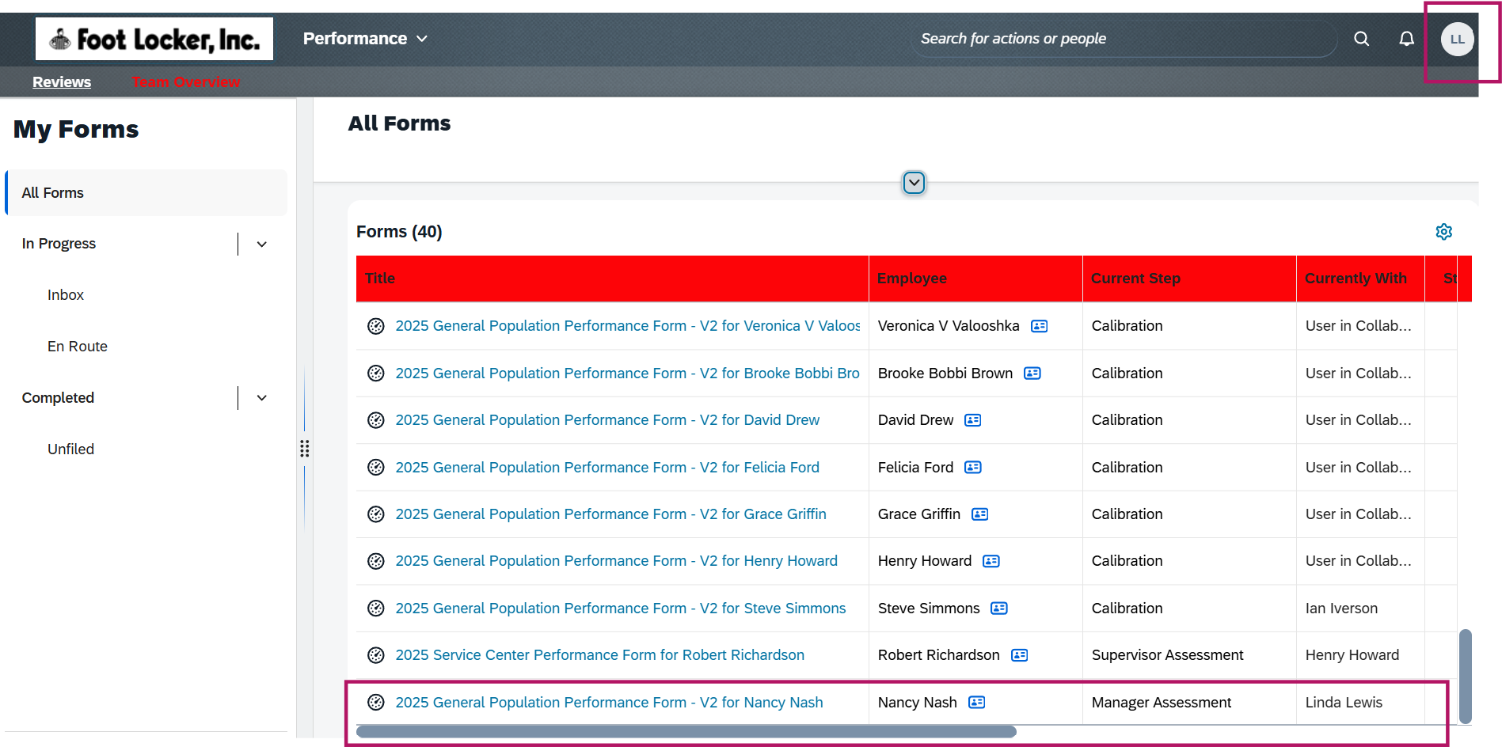

Proxying as Manager – Felicia Ford
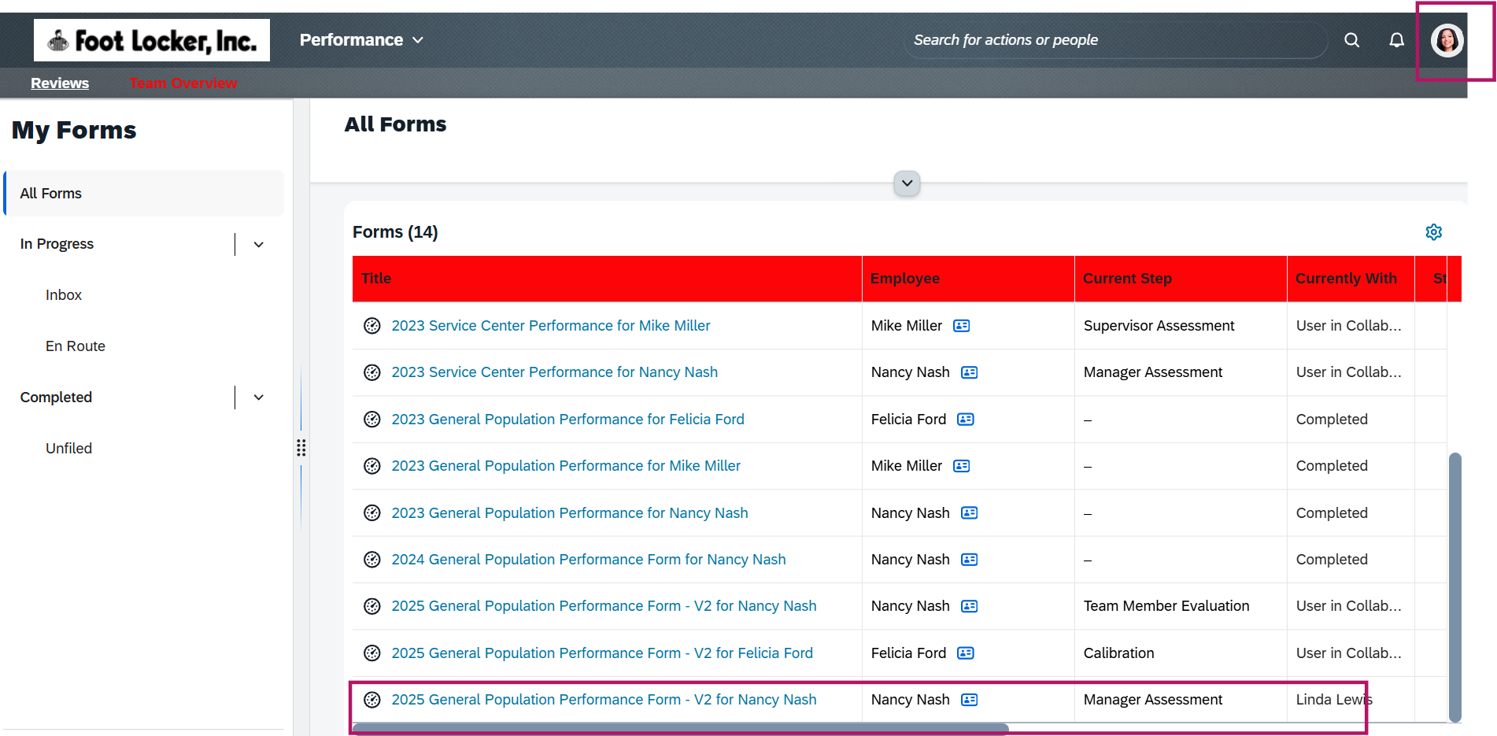

Ask for feedback – proxying as manager – asking for feedback from Mike Miller and Henry Howard
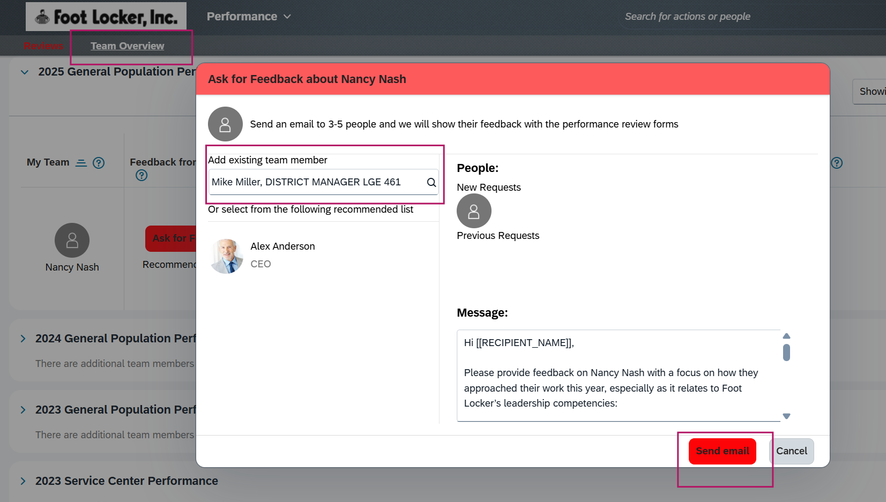

Feedback fed over to the designated TM's performance form and appear in the top "Support Information" tab on the performance form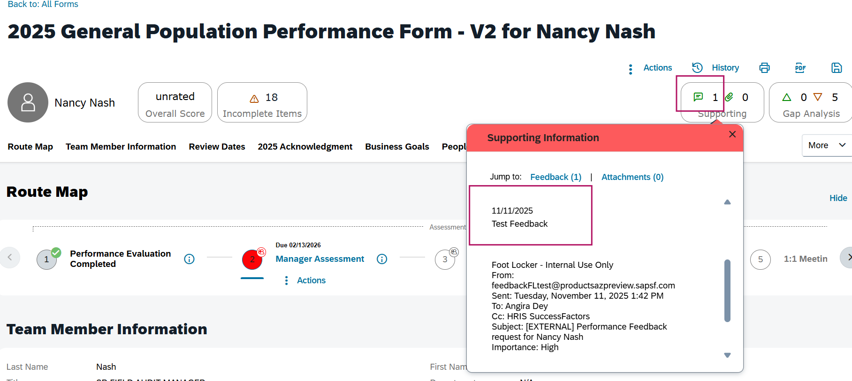
Adjusted Calculated Rating will be generated after the form is saved, closed and reopened. Manager’s Overall rating will still be ‘Unrated’
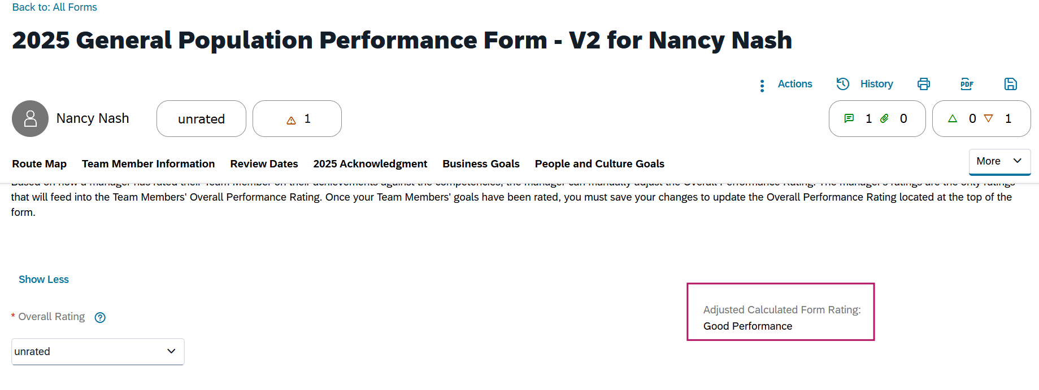
Gap analysis is being displayed on the top right corner of the form.
Manager now inputs the Overall rating and moves the form to the next step of Team member evaluation.
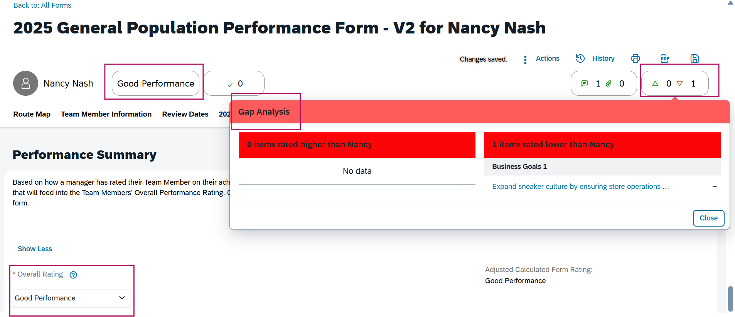
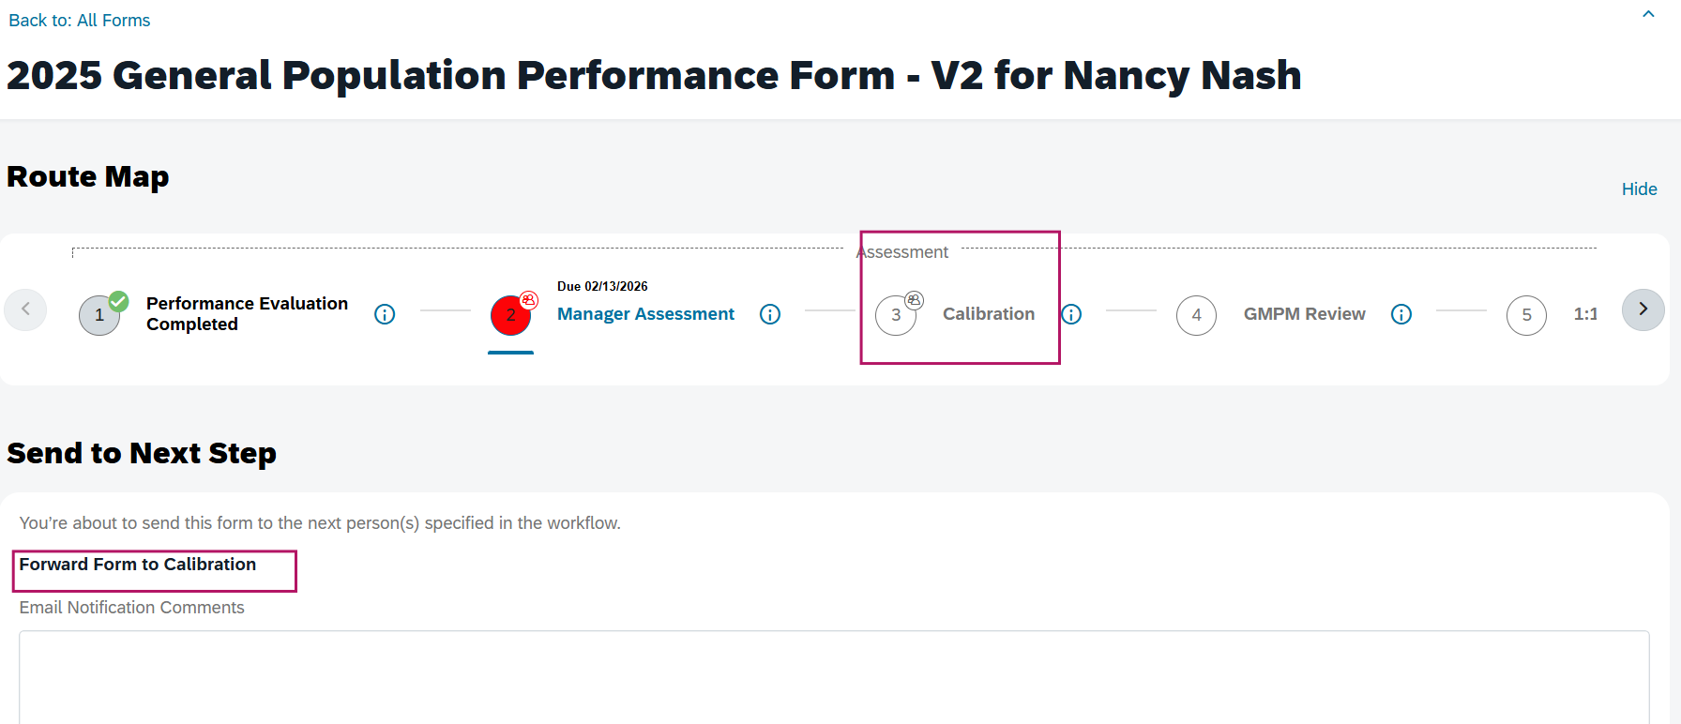
When the form is in calibration step, proxy as Manager and HR Champion to validate they both can view Team member’s Performance form’s details.
Manager moves the form to the next step : GMPM Review
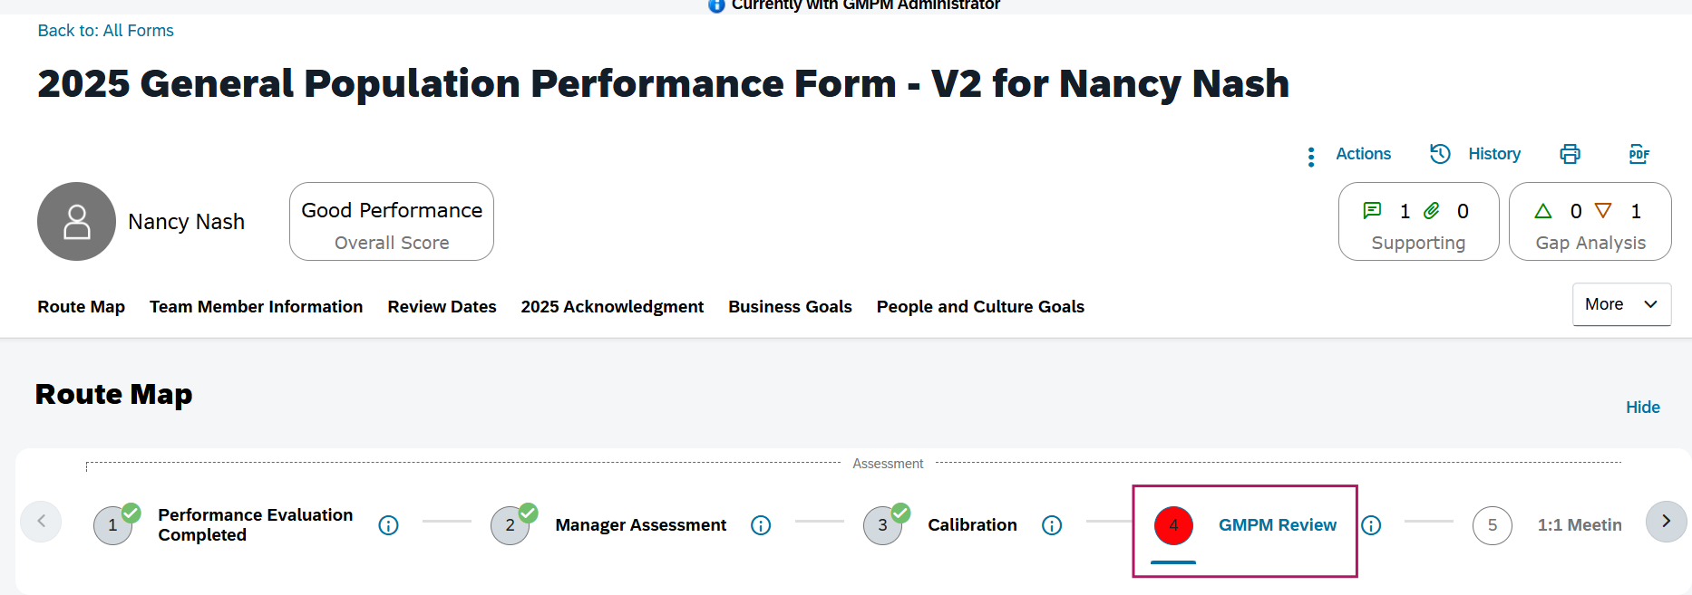

Proxy as GMPM administrator
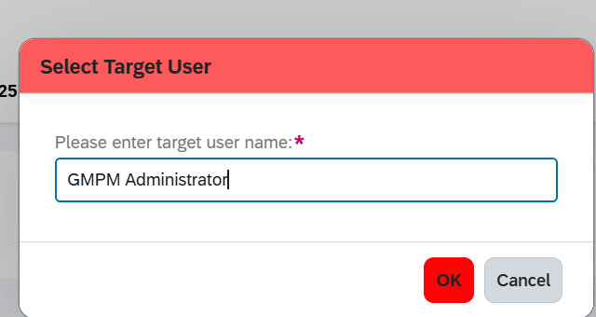
Stack ranker: Overall rank of the team member in the Performance form
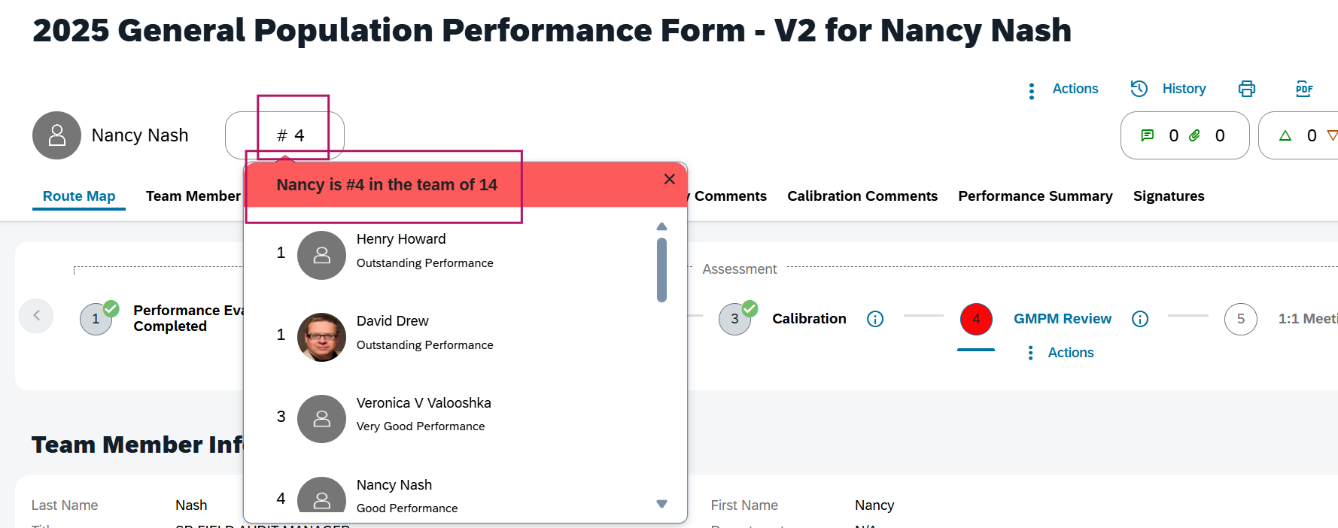

The form will be forwarded to the Manager
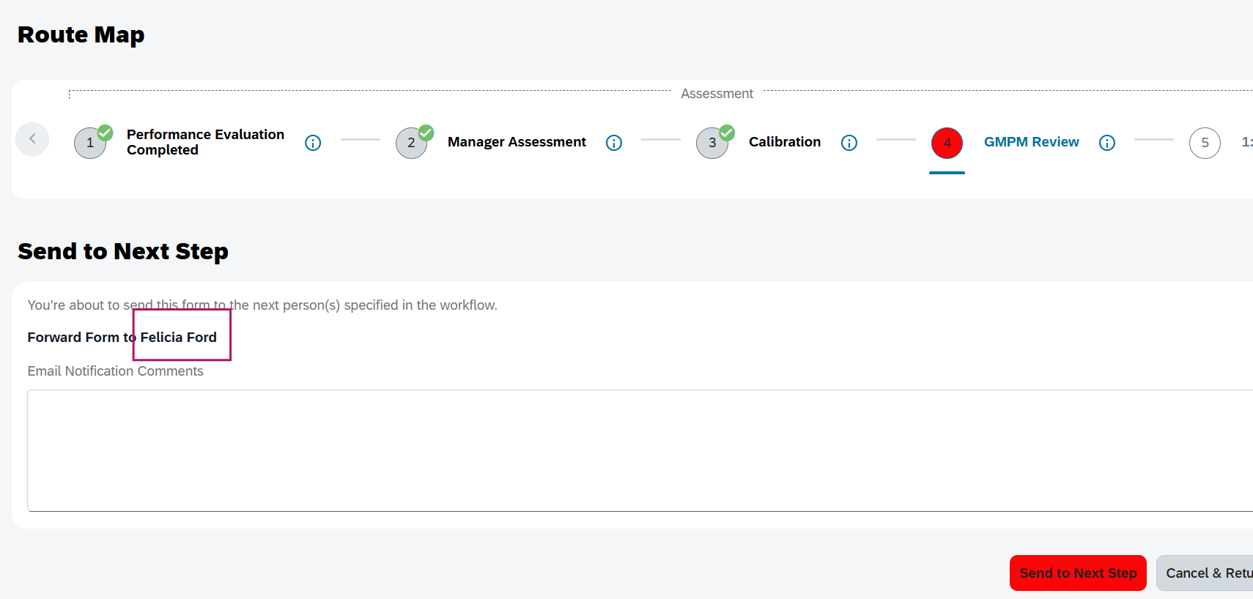

1:1 meeting
The form can be printed and saved in pdf version
Supporting information section is not visible in this step on the top Right hand side
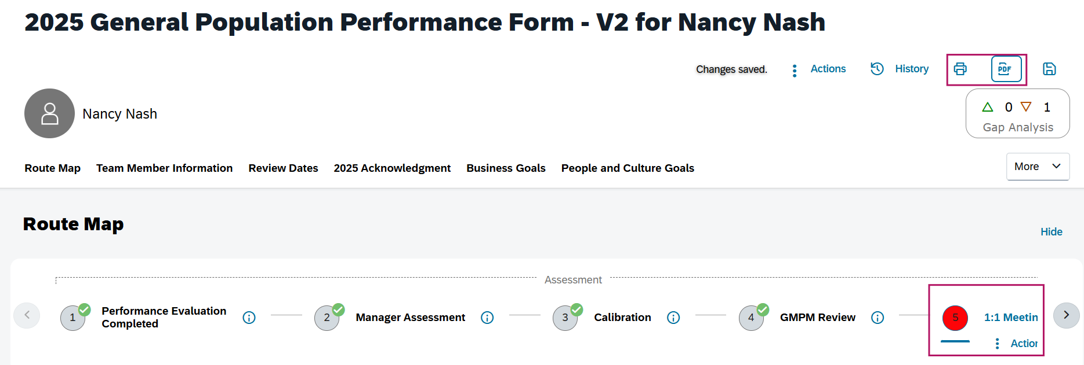
The form will be forwared to the Team member for 1:1 meeting
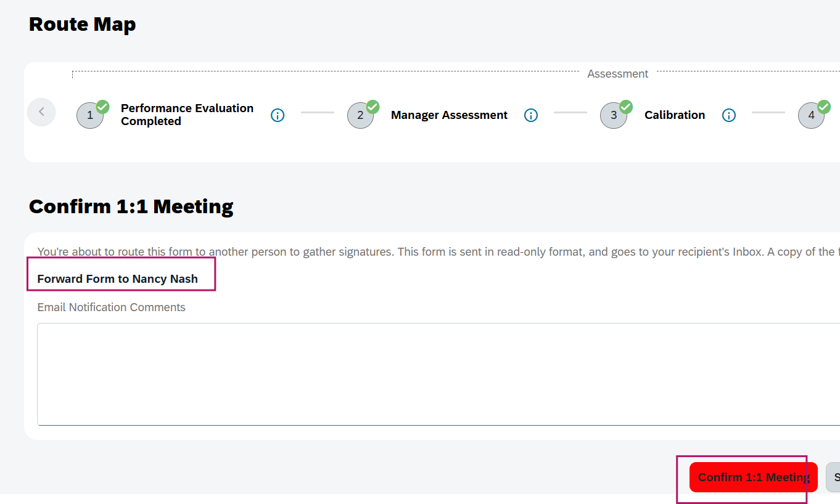

Team member Signature:
TM can view the final score of the performance form.
TM do not have edit rights to the comments and ratings anymore
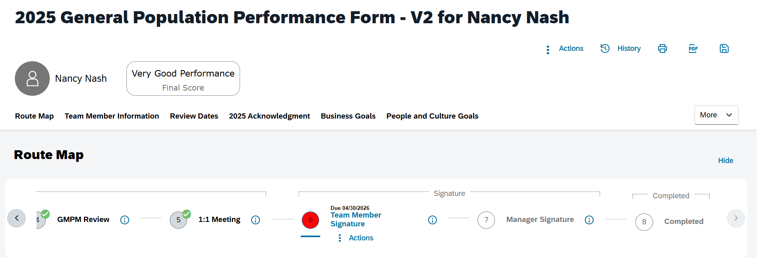

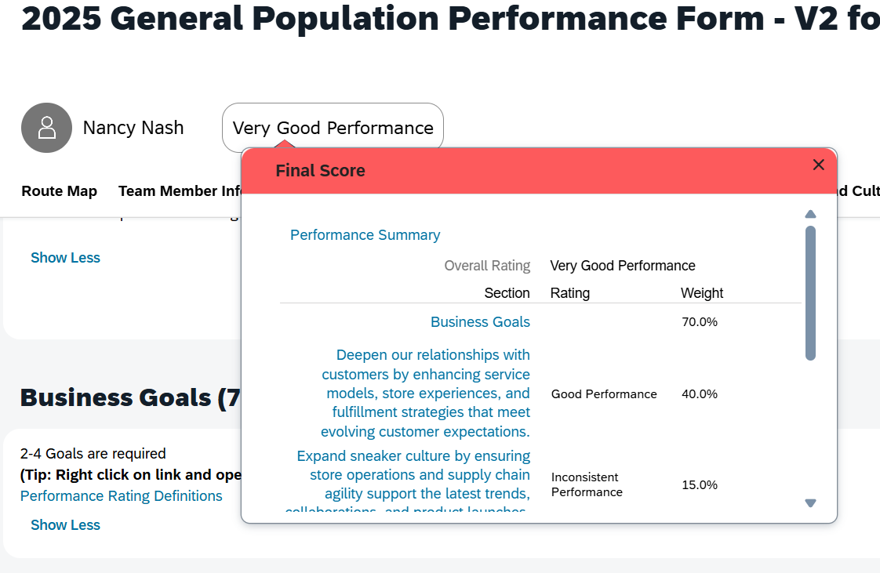
TM can view the Overall rating (Final rating), but cannot view the Adjusted rating
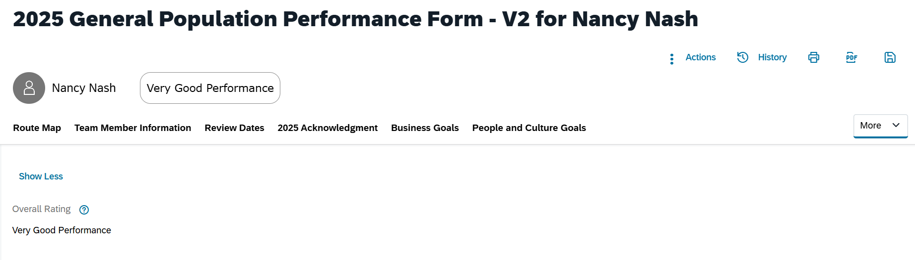

TM signs the form and forwards the form to the next step : Manager Signature

Manager Signature: This is the last step of the process.
Manager signs the form.
Manager, TM and HR Champion- all will get a copy of the Team member’s performance form copy in their email.

